NLP Journal
1} PRACTICAL1_Tokenization
- Perform Sentence Tokenization:
- Perform Word Tokenization:
- Display the List of Tokens:

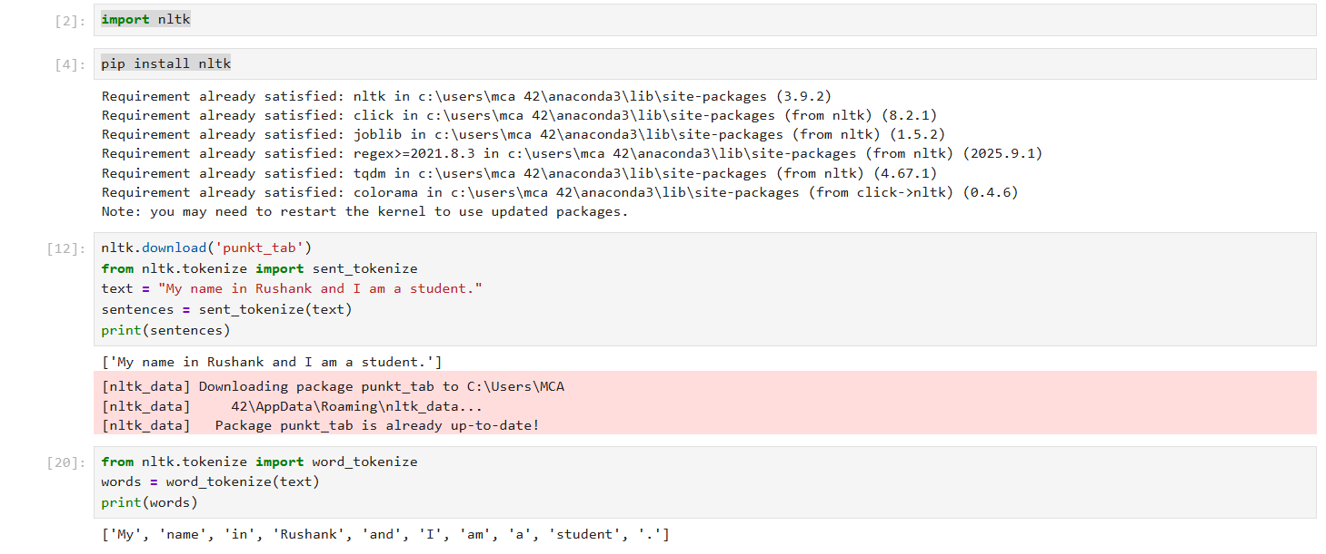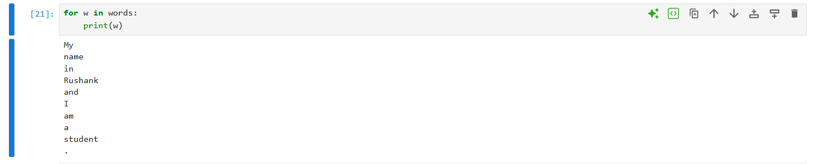

2} PRACTICAL2_Stemming
- Remove English Stop word from tokenization words
- Display the filtered word list

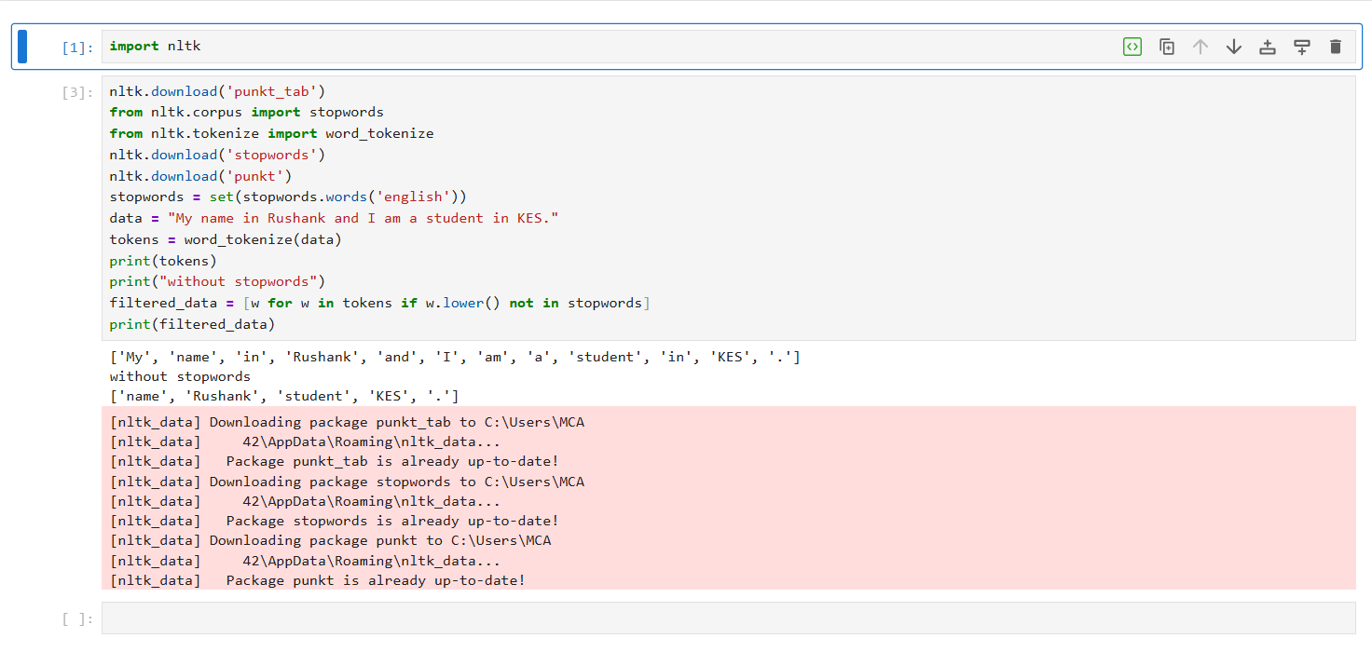
3} PRACTICAL3_Stemming
- Apply Porter’s stemmer on the filtered words
- Display the Stemmed output

